ME8593 DESIGN OF MACHINE ELEMENTS L T P C 3 0 0 3
OBJECTIVES
- To familiarize the various steps involved in the Design Process.
- To understand the principals involved in evaluating the shape and dimensions of a component to satisfy functional and strength requirements.
- To learn to use standard practices and standard data.
- To learn to use catalogues and standard machine components.
(Use of P S G Design Data Book is permitted)
UNIT I STEADY STRESSES AND VARIABLE STRESSES IN MACHINE MEMBERS 9
Introduction to the design process - factors influencing machine design, selection of materials based on mechanical properties - Preferred numbers, fits and tolerances – Direct, Bending and torsional stress equations – Impact and shock loading – calculation of principle stresses for various load combinations, eccentric loading – curved beams – crane hook and ‘C’ frame- Factor of safety - theories of failure – Design based on strength and stiffness – stress concentration – Design for variable loading.
UNIT II SHAFTS AND COUPLINGS 9
Design of solid and hollow shafts based on strength, rigidity and critical speed – Keys, keyways and splines - Rigid and flexible couplings.
UNIT III TEMPORARY AND PERMANENT JOINTS 9
Threaded fasteners - Bolted joints including eccentric loading, Knuckle joints, Cotter joints – Welded joints, riveted joints for structures - theory of bonded joints.
UNIT IV ENERGY STORING ELEMENTS AND ENGINE COMPONENTS 9
Various types of springs, optimization of helical springs - rubber springs - Flywheels considering stresses in rims and arms for engines and punching machines- Connecting Rods and crank shafts.
UNIT V BEARINGS 9
Sliding contact and rolling contact bearings - Hydrodynamic journal bearings, Sommerfield Number, Raimondi and Boyd graphs, -- Selection of Rolling Contact bearings.
TOTAL: 45 PERIODS

TEXT BOOK:
- Bhandari V, “Design of Machine Elements”, 3rd Edition, Tata McGraw-Hill Book Co, 2010.
- Joseph Shigley, Charles Mischke, Richard Budynas and Keith Nisbett “Mechanical Engineering Design”, 8th Edition, Tata McGraw-Hill, 2008.

REFERENCES:
- Alfred Hall, Halowenko, A and Laughlin, H., “Machine Design”, Tata McGraw-HillBookCo.(Schaum’s Outline), 2010
- Ansel Ugural, “Mechanical Design – An Integral Approach", 1st Edition, Tata McGraw-Hill Book Co, 2003.
- P.C. Gope, “Machine Design – Fundamental and Application”, PHI learning private ltd, New Delhi, 2012.
- R.B. Patel, “Design of Machine Elements”, MacMillan Publishers India P Ltd., Tech-MaxEducational resources, 2011.
- Robert C. Juvinall and Kurt M. Marshek, “Fundamentals of Machine Design”, 4th Edition, Wiley, 2005
- Sundararajamoorthy T. V. Shanmugam .N, “Machine Design”, Anuradha Publications,Chennai, 2015.

ME8593 - DESIGN OF MACHINE ELEMENTS COURSE OUTCOMES
On completion of this course, the student will be able:

C302.1 | To explain the influence of steady and variable stresses in machine component design.
C302.2 | To apply the concepts of design to shafts, keys and couplings.
C302.3 | To apply the concepts of design to temporary and permanent joints.
C302.4 | To apply the concepts of design to energy absorbing members, connecting rod and crankshaft.
C302.5 | To apply the concepts of design to bearings.

MAPPING BETWEEN CO, PO AND PSO WITH CORRELATION LEVEL 1/2/3

ME8593 | PO1 | PO2 | PO3 | PO4 | PO5 | PO6 | PO7 | PO8 | PO9 | PO10 | PO11 | PO12 | PSO1 | PSO2 | PSO3
C302.1 | 3 | 3 | - | - | 3 | 1 | 1 | 3 | - | - | - | 1 | 3 | 2 | 2
C302.2 | 3 | 3 | - | - | 3 | 1 | 1 | 3 | - | - | - | 1 | 3 | 2 | 2
C302.3 | 3 | 3 | - | - | 3 | 1 | 1 | 3 | - | - | - | 1 | 3 | 2 | 2
C302.4 | 3 | 3 | - | - | 3 | 1 | 1 | 3 | - | - | - | 1 | 3 | 2 | 2
C302.5 | 3 | 3 | - | - | 3 | 1 | 1 | 3 | - | - | - | 1 | 3 | 2 | 2

RELATION BETWEEN COURSE CONTENT WITH COs

UNIT I - STEADY STRESSES AND VARIABLE STRESSES IN MACHINE MEMBERS

S.No | Knowledge level | Topics | Course Outcomes
1 | U | Introduction to the design process. | C302.1
2 | U | Factors influencing machine design, selection of materials based on mechanical properties. | C302.1
3 | U,E | Preferred numbers, fits and tolerances. | C302.1
4 | U, Ap,E | Direct, Bending and torsional stress equations. | C302.1
5 | U | Impact and shock loading. | C302.1
6 | U,Ap,E | Calculation of principle stresses for various load combinations, eccentric loading. | C302.1
7 | U,Ap,An,E | Curved beams, crane hook and ‘C’ frame, Factor of safety. | C302.1
8 | U,E | Theories of failure, Design based on strength and stiffness. | C302.1
9 | U | Stress concentration. | C302.1
10 | U,E | Design for variable loading. | C302.1

UNIT II: SHAFTS AND COUPLINGS

S.No | Knowledge level | Topics | Course Outcomes
1 | U,Ap,An,E | Design of solid and hollow shafts based on strength, rigidity and critical speed. | C302.2
2 | U,Ap,An,E | Keys, keyways and splines. | C302.2
3 | U,Ap,An,E | Rigid and flexible couplings. | C302.2

UNIT III: TEMPORARY AND PERMANENT JOINTS

S.No | Knowledge level | Topics | Course Outcomes
1 | U | Threaded fasteners. | C302.3
2 | U,Ap,An,E | Bolted joints including eccentric loading, Knuckle joints, Cotter joints. | C302.3
3 | U,Ap,An,E | Welded joints, riveted joints for structures. | C302.3
4 | U,Ap,An,E | Theory of bonded joints. | C302.3

UNIT IV: ENERGY STORING ELEMENTS AND ENGINE COMPONENTS

S.No | Knowledge level | Topics | Course Outcomes
1 | U | Various types of springs, optimization of helical springs. | C302.4
2 | U,Ap,An,E | Rubber springs. | C302.4
3 | U,Ap,An,E | Flywheels considering stresses in rims and arms for engines and punching machines. | C302.4
4 | U,Ap,An,E | Connecting Rods and crank shafts. | C302.4

UNIT V: BEARINGS

S.No | Knowledge level | Topics | Course Outcomes
1 | U,Ap,An,E | Sliding contact and rolling contact bearings | C302.5
2 | U,Ap,An,E | Hydrodynamic journal bearings, Sommerfeld Number, Raimondi and Boyd graphs. | C302.5
3 | U,Ap,An,E | Selection of Rolling Contact bearings. | C302.5

Ap – Apply; An – Analyze; U – Understand, E- Evaluate, C-Create

UNIT-1 STEADY STRESSES AND VARIABLE STRESSES IN MACHINE PARTA (C302.1)
- What are preferred numbers? [April / May 2018]
The preferred numbers are the conventionally rounded off values derived from geometric series including the integral powers of 10 and having as common ratio of the following factors:⁵√10,

10√10, ²⁰√10 and ⁴⁰√10.

Brief about Soderberg and Goodman lines. [April / May 2018]
Soderberg Line: A straight line joining Se on the ordinate to yield stress on the abscissa is called the Soderberg line. Where Se is the intersection point of Goodman line and Soderberg line on the ordinate.
Goodman Line: A straight line joining Se on the ordinate to ultimate stress on the abscissais called the Goodman line.

What is shock factor and what does it indicate? [Nov / Dec 2017, Nov / Dec 2018]
According to A.S.M.E. code, the bending and twisting moment are to be multiplied by factors kb and kt respectively, to account for shock and fatigue in operatingcondition.
- Differentiate Hardness and toughness. [Nov / Dec 2017, Nov / Dec 2018] Hardness is the ability of material to resist scratching and indentation.
Toughness is the ability of a material to absorb energy and plastically deform without fracturing.

Define modulus of resilience and proof resilience. [May / June 2017]
Proof resilience is defined as the maximum energy that can be absorbed up to the elastic limit, without creating a permanent distortion. The modulus of resilience is defined as the maximum energy that can be absorbed per unit volume without creating a permanent distortion.

How the machine design may be classified? [Nov / Dec 2017]
The machine design may be classified as follows.
  - Adaptive design b) Developed design c) New design
d) Rational design e) Empirical design f) Industrial design

What is an S-N curve? [Nov / Dec 2016]
An S-N curve has fatigue stress on Y axis and number of loading cycles in X axis. It is used to find the fatigue stress value corresponding to a given number of cycles.
- Define stress concentration [May / June 2016] Stress concentration is the increase in local stresses at points of rapid change in cross section or discontinuities.
- Describe the material properties of stiffness and resilience. [May / June 2016] Stiffness is the ability of material to resist deformation under loading.
Resilience is the ability of material to resist absorb energy and to resist shock and impact load.

Which theory of failure is suitable for the design of brittle materials? [Nov / Dec 2015]
Maximum principal stress (or) maximum normal stress (or) Rankine theory is suitable for designing brittle material.

What are the common materials used in mechanical engineering design? [Nov / Dec 2015]
1. Plain carbon steel, 2. Steel with alloying elements, 3.Stellite, 4. Ceramics
5. Copper, 6. Aluminium.

Define limits and fits. [May / June 2015]
The extreme permissible values of a dimension are known as limits. The degree of tightness or looseness between two mating parts that are intended to act together is known as the fit of the parts.

What is an adaptive design? [April / May 2015]
In most cases, the designer’s work is concerned with adaptation of existing designs. This type of design needs no special knowledge or skill and can be attempted by designers of ordinary technical training. The designer only makes minor alternation or modification in the existing designs of the product.

Determine the force required to punch a hole of 20mm diameter in a 5mm thick plate with ultimate shear strength of 250Mpa? [Nov / Dec 2014]
Shear force, F = Shear stress x Area
F = 250 x π x 20 x 5 F = 78.539kN

Define creep.
When a part is subjected to a constant stress at high temperature for a long period of time, it will undergo a slow and permanent deformation called creep.

List at least two methods to improve the fatigue strength. [N/D 2014, 2019]
Cold working like shot peening, burnishing, Heat Treatment like induction hardening, case hardening, nitrating and Pre Stressing or Auto Fretting.

What is eccentric load and eccentricity?
An external load, whose line of action is parallel but does not coincide with the centroidal axis of the machine component, is known as an eccentric load .the distance between the centroidal axis of the component and the eccentric load is called eccentricity.

Define endurance limit. [Nov / Dec 2019]
Endurance limit is the maximum value of completely reversed stress that the standard specimen can sustain an infinite number (106) of cycles without failure.

Differentiate between repeated stress and reversed stress.
Repeated stress refers to a stress varying from zero to a maximum value of same nature.
Reversed stress of cyclic stress varies from one value of tension to the same value of compression.

List out the factors involved in arriving at factor of safety. [Nov / Dec 2011]
i. Material properties ii. Nature of loads iii. Presence of localized stresses
iv. Mode of failures , v. Presence of initial stresses

What are the factors affecting selection of material for machine element? [Nov / Dec 2019]
The factors affecting selection of material for machine element are,
  - Load applied b) Purpose and operating conditions of the part
c) Suitability for manufacture d) Minimum weight and optimal size
e) Availability and cost.

Give some methods of reducing stress concentration. [Nov / Dec 2012, 2019]
i) Avoiding sharp corners, ii) providing fillets, iii) Use of multiple holes instead of single hole,
iv) Undercutting the shoulder parts.

Which theory of failure is suitable for the design of cast iron component subjected to steady state loading? [June/July 2021]
Maximum Principal Stress Theory (or) Normal Stress Theory (or) Rankine’s Theory is suitable for the design of cast iron component subjected to steady state loading. Since the maximum principal or normal stress theory is based on failure in tension or compression and ignores the possibility of failure due to shearing stress, therefore it is not used for ductile materials. However, for brittle materials which are relatively strong in shear but weak in tension or compression, this theory is generally used.

A component is loaded with normal and shear stresses as σx= 15 MPa, σy = 5 MPa, and τxy = 10 MPa. Find the maximum shear stress developed in the component. [June/July 2021]
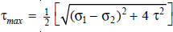
Given: σx= σ1 =15 MPa, σy = σ2 = 5 MPa, τxy = 10 MPa
τ _{max} = 11.18 MPa

PART --- B(C302.1)

- A hypothetical machine member by 50mm in diameter and 250mm long is supported in one end as cantilever is subjected to various types of loadings, as shown below. Find the principal stresses and maximum shear stress in each case. (i) Axial Load 15kN (ii) Transverse load 3kN at the free end
(iii) Twisting moment of 1kNm at the free end, clockwise, while viewing from free end side (iv) (i) and (ii) together (v) (i), (ii) and (iii) together. [Nov / Dec 2018]
- The C-frame of a 100kN capacity press is shown in figure 1. The material of the frame is gray cast iron FG 200 and factor of safety is 3. Determine the dimensions of the frame. [Nov / Dec 2018, 2019]
- A wall bracket with rectangular cross section is shown in figure 2. The depth of the cross section is twice that of the width. The force P acting on the bracket at 60º to the vertical is 5 kN. The material of the bracket is grey cast iron FG 200 and the factor of safety is 3.5. Determine the dimensions of the cross sections of the bracket. Assume maximum normal stress theory of failure.[April 2018]

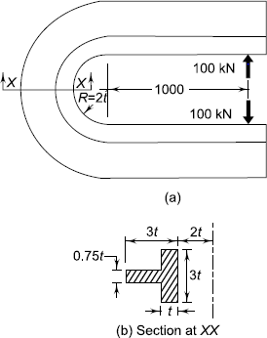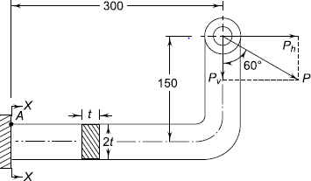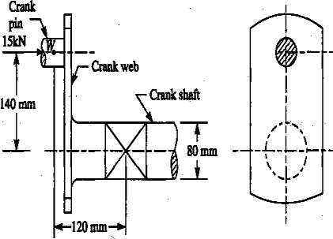
Figure: 1 Figure: 2 Figure: 3
- The shaft of an overhang crank is subjected to a force F of 2kN as shown in figure 3above. The shaft is made of 30Mn2steel having allowable shear strength equal to100N/mm². Determine the diameter of the shaft. [April / May 2015]
- A mass of 50kg drops through 25mm at the centre of a 250mm long simply supported beam. The beam has a square cross section. It is made of steel 30C8 (Syt =400N/mm²) and the F.O.S is 2. The modulus of elasticity is 207000N/mm² .Determine the dimensions of the cross section of the beam.

[Nov / Dec 2017]
6.A wall crane with a pin joint tie rod is as shown in figure4 below. The crane hook is to take a maximum load 35kN, when the load is at a distance of 2m from the wall. The tie rod and pin are made of steel FeG (Syt = 250N/mm²) and the FOS is 5. Calculate the diameter of tie rod and the pin.

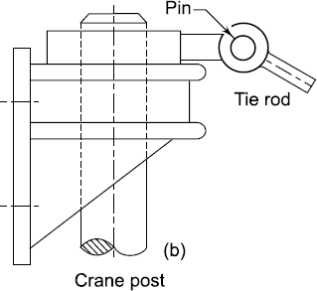
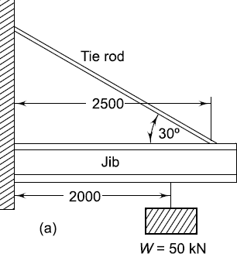
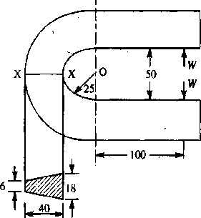
[May / June 2017]

Figure: 4 Figure: 5
- The frame of a punch press is shown in figure5. Find the stresses at the inner and outer surface at section X-X of the frame, if W= 5000N. Section at X-X; All dimensions in mm
- A C-clamp is subjected to a maximum load of W, as shown in figure 6. If the maximum tensile stress in the clamp is limited to 140MPa, find the value of load W. Section of X-X; all dimensions in mm. [Nov / Dec 2012, May / June 2014]

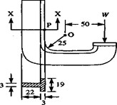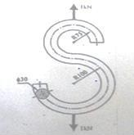
Figure: 6 Figure: 7
- A link shaped in the form of a letter S is made up of 30mm diameter bar, as shown in figure7. Determine the maximum tensile stress and maximum shear stress in the link. [April / May 2017]
- A circular bar of 500mm is supported freely at its two ends. It is acted upon by a central concentrated load having a minimum value of 20kN and a maximum value of 50kN. Determine the diameter of bar by taking a factor of safety 1.5, size effect of 0.85, surface finish factor of 0.9. The material properties of bar at given by: ultimate strength of 650Mpa, yield strength of 500MPa and endurance strength of 350MPa. [Dec / Dec 2016]
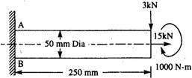
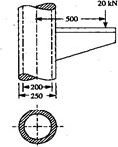
11.A hollow circular column of external diameter 250mm and internal diameter 200mm carries a projecting bracket on which a load of 20kN rests, as shown in figure8. The centre of the load from the centre of the column is 500mm. Find the stresses at the sides of the column. All dimensions in mm. [Nov / Dec 2016, 2019]
Figure: 8 Figure: 9
  - shaft, as shown in figure 9, is subjected to a bending load of 3kN, pure torque of 1000N-m and an axial pulling force of 15kN. Calculate the stresses at A and B. All dimensions in mm.
[May / June 2016, 2019] bolt is subjected to a direct load of 25kN and shear load of 15kN.Considering following theories of failure, determine a suitable size of the bolt if the material of the bolt is C15 having 200N/mm² yield strength. Assume F.O.S as 2 and also give your comments
    - Maximum Normal stress theory (ii)Maximum shear stress theory
(iii)Von Misses theory. [Nov / Dec 2017, 2019]

14. A steel cantilever is200 mm long. It is subjected to an axial load which varies from 150N (compression) to 450N (tension) is shown in figure 10 and also a transverse load at its free end which varies from 80N up to 120N down. The cantilever is of circular cross-section. It is of diameter 2d for the first 50mm and of diameter‘d’ for the remaining length. Determine its diameter taking a factor of safety of 2. Assume the following values:
Yield stress = 330Mpa
Endurance limit in reversed loading = 300Mpa
Correction factor =0.7 in reversed axial Loading
= 1.0 in reversed Bending
Stress concentration factor = 1.44 for bending = 1.64 for axial loading
Size effect factor | = 0.85
Surface effect factor | = 0.90
Notch sensitivity index | = 0.90 | [April / May 2016]
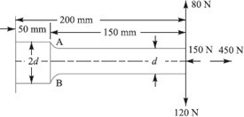
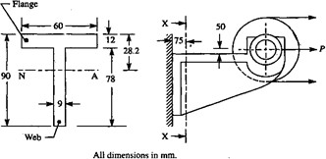

Figure: 10 Figure: 11
15.A cantilever rod of length 120mm with circular section is subjected to a cyclic transverse load, varying from -100 N to 300N at its free end. Determine the diameter‘d’ of the rod by (i) Goodman method and (ii) Sooderberg method using the following data. FOS=2. Theoretical stress concentration factor=1.4, Notch sensitivity factor=0.9, ultimate strength=550Mpas, Yield strength=320Mpas, Endurance limit = 275Mpas, Size correction factor = 0.85, Surface correction factor=0.9.

[Nov / Dec 2015]
16.A pulley is keyed to a shaft midway between two bearings. The shaft is made of cold drawn steel for which the ultimate strength is 550MPa and the yield strength is 400MPa.The bending moment at the pulley varies from –150 N-m to +400N-m as the torque on the shaft varies from–50N-m to
+150N-m. Obtain the diameter of the shaft for an indefinite life. The stress concentration factors for the keyway at the pulley in bending and in torsion are1.6 and 1.3 respectively. Take the following values:
Factor of safety | = | 1.5
Load correction factors | = | 1.0 in bending, and 0.6 in torsion
Size effect factor = 0.85  Surface effect factor | = | 0.88 [Nov / Dec 2012, 2019]

- A hollow shaft of 40mm outer diameter and 25mm inner diameter is subjected to a twisting moment of 120N-m, simultaneously it is subjected to an axial thrust of 10kN and a bending moment of 80N-m. Calculate the maximum compressive and shear stresses. [May/ June 2014]
- A horizontal pull P= 5kN is exerted by the belting on one of the cast iron wall brackets which carry a factory shafting. At a point 75mm from the wall, the bracket has a T-section as shown in figure
11. Calculate the maximum stresses in the flange and web of the bracket due to the pull.
- A cantilever beam of rectangular cross-section is used to support a pulley as shown in Fig. 12. The tension in the wire rope is 10 kN. The beam is made of cast iron whose ultimate strength σut= 240 MPa and the factor of safety is 3. The ratio of depth to width of cross-section is 2. Determine the dimensions of the cross-section of the beam. [June 2021]
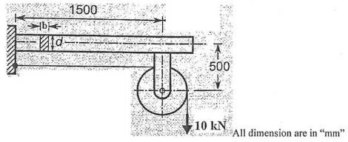
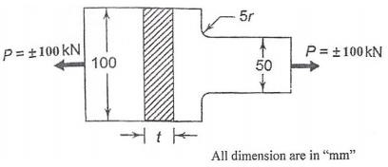
- A component machined from a plate made of 45C8 (σu= 650 MPa) as shown in Fig. 13. It is subjected to a completely reversed axial force of 100 kN. The reliability factor, kc = 0.897; factor of safety = 2. The size factor, kb = 0.8, surface finish factor, ka = 0.76. Determine the thickness of the plate, for infinite life, if the notch sensitivity factor, q = 0.8. [June 2021]
Figure: 12 Figure: 13

PARTC (C302.1)
- A 50mm wide, 5mm high rectangular plate has 5mm diameter central hole. The allowable tensile stress is 700MPa. Find (i) The maximum tensile force that can be applied (ii) the maximum bending Moment that can be applied to reach the maximum stress (iii) the maximum tensile force and the maximum bending moment if the hole is not present. Express the results as a ratio when compared to parts (i) and (ii). [Nov / Dec 2018]
- Determine the stress at points A and B split ring shown in figure 12. If a compressive force = 20kN is applied point ‘C’.
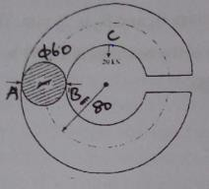
Figure: 12

- A Machine component is subjected to a flexural stress which fluctuates between +300MN/m² and
-150MN/m² .Determine the value of minimum ultimate strength according to
  - Gerber relation
  - Modified Goodman relation and (iii)Soderberg relation.
Take Yield strength=0.55 ultimate strength;
Endurance strength=0.5 ultimate strength; and FOS=2 [Nov / Dec 2017, 2019]
- A solid circular shaft of diameter 45mm is loaded by bending moment 650Nm, torque 900Nm and an axial tensile force of 30kN. The shaft material is ductile with yield strength of 280Mpa. Determine the factor of safety according to maximum principal stresses, Tresca and von misses theories of failure. [April / May 2017]
UNIT- II DESIGN OF SHAFTS AND COUPLINGS PART A (C302.2)
- Write the advantages that hollow shafts offer as compared to solid shafts. [April / May 2018]
  - In hollow shaft, the material at the centre is removed and spread at large radius. Therefore, hollow shafts are stronger than solid shaft having the same weight.
  - The stiffness of the hollow shaft is more than the solid shaft with same weight.
  - The strength of the hollow shaft is more than the solid shaft with same weight.

Write Rayleigh-Ritz equation to determine the critical speed of shaft subjected to point loads.
[April / May 2018]
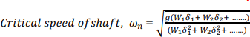

Where,
ωn = first or lowest critical speed (rad/s), g = gravitational constant (9.81 m/s) W1= m1g W2 = m2 g
m1, m2, m3… = rotating masses (kg), d1, d2, d3... = static deflections at the respective masses

Differentiate between rigid coupling and flexible coupling.
[April / May 2016, Nov / Dec 2017, Nov / Dec 2018, April, May 2019, June2021]

Rigid coupling | Flexible coupling
- It restricts the misalignment between two shafts.  - Simple and inexpensive | - It can tolerate misalignment between two shafts.  - Costly due to additional parts and more popular.

List the different types of sunk keys and draw any one. [Nov / Dec 2017, Nov / Dec 2018]
1. Parallelkeys 2. Woodruff keys 3. Tapered keys 4. Sunk key 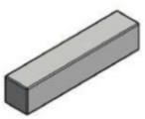

State the reasons for which the couplings are located near the bearings. [April / May 2017]
Couplings tend to produce unbalanced forces due to misalignments of shafts which cause vibrations in rotating machinery. How much ever the bearing is closer to coupling, the lesser overhang is there. Leading to lower amplitude of vibrations.

Define the term critical speed. [Nov / Dec 2016, 2019]
The speed, at which the shaft runs so that the additional deflection of the shaft from the axis of rotation becomes infinite, is known as critical or whirling speed.
- What are the types of flexible coupling and rigid couplings? [Nov / Dec 2016, 2019] Flexible coupling: Bushed pin type coupling, Universal coupling and Oldham coupling Rigid Coupling: Box or muff coupling, Clamp coupling and Flange coupling

What is the effect of keyways cut into the shaft? [April / May 2016, 2019]
The keyway cut into the shaft reduces the load carrying capacity of the shaft. This is due to the stress concentration near the corners of the keyway and reduction in the cross-sectional area of the shaft. In other words, the Torsional strength of the shafts is reduced.

What is meant by design of a shaft based on rigidity? [Nov / Dec 2015]
The shaft is to be designed by considering torsional rigidity as well as lateral rigidity. Design based on rigidity is to ensure that maximum deflection (because of bending) and maximum twist (due to torsion) of the shaft is within the allowable limits. Rigidity consideration is also very important in some cases for example position of a gear mounted on the shaft will change if the shaft gets deflected and if this value is more than some allowable limit, it may lead to high dynamic loads and noise in the gears.

What are the possible modes of failure of the pin (bolt) in a flexible coupling
[Nov / Dec 2015]
Following are the possible modes of failure of the pin (bolt)in a flexible coupling: i) Bearing failure, ii) Shear failure, iii) Bending failure, iv) Tensile failure due to combined bending and shear stress

What is the difference between spindle and axle? [April / May 2015]
An Axle is a type of shaft used for rotating a gear or a wheel. The axle may be fixed to the vehicle with the wheels rotating around it, or may be fixed to the wheels such that both the axle and the wheels rotate together. The former orientation of the axle is sometimes referred to as a Spindle.

What are the various forces acting on a sunk key? [Nov / Dec 2014]
The various forces acting on a sunk key are, a) Forces due to fit of the key in its keyway,
b) Forces due to torque transmitted by the shafts.

What are the various stresses induced in the shafts? [April / May 2014, 2019]
The following stresses are induced in the shafts. Bending stresses (tensile or compressive) due to the forces acting upon the machine elements like gears and pulleys as well as the self-weight of the shaft.

What is woodruff key? State its main application. [Nov / Dec 2014]
Woodruff key is piece from a cylindrical disc having segmental cross section. A woodruff

key is capable of tilting in a recess milled out in the shaft by a cutter having the same curvature as the disc from which the key is made. They are largely used in machine tools and automobile constructions.

Why a hollow shaft has greater strength and stiffness than solid shaft of equal weight?
Stresses are maximum at the outer surface of a shaft. A hollow shaft has almost all the material concentrated at the outer circumferences and so has a better strength and stiffness for equal weight.

What are splines?
The keys are made integral with the shaft which fits in the keyways broached in the hub. Such shafts are known as splined shafts. These shafts usually have four, six, ten or sixteen splines. The splined shafts are relatively stronger than shafts having a single keyway.

What is the function of a coupling between two shafts? [Nov / Dec 2014]
Couplings are used to connect sections of long transmission shafts and to connect the shaft of a driving machine to the shaft of a driven machine.

What is principal stress and principle plane?
A plane which has no shear stress is called principle plane and the corresponding stress is called principle stress.

What are the standard sizes of transmission shafts?
The standard sizes of transmission shafts are,
- 25 mm to 60 mm with 5 mm steps b) 60 mm to 110 mm with 10 mm steps
- 110 mm to 140mm with 15 mm steps d) 140 mm to 500 mm with 20 mm steps

On what basis the shafts are designed?
- Based on rigidity and stiffness, b) Based on strength, c) Based on critical speed.

What are the purposes in machinery for which couplings areused?
1. To provide misalignment of the shafts (or) to introduce mechanical flexibility, 2. To reduce the transmission of shock from one shaft to another, 3.To introduces protection against over load.

Why a hollow shaft has greater strength and stiffness than solid shaft of equal weight?
[Nov/ Dec 2012]
Stresses are maximum at the outer surface of a shaft. A hollow shaft has almost all the material concentrated at the outer circumferences and so has a better strength and stiffness for equal weight.

Define equivalent bending moment. [June 2021]

The equivalent bending moment may be defined as that moment which when acting alone Produces the same tensile or compressive stress (σb) as the actual bending moment. By limiting the maximum normal stress [σb(max)] equal to the allowable bending stress (σb), then the equation may be written as
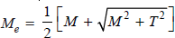

PART B (C302.2)
1.A section of a commercial shafting 2m long between bearings carries a 1000N pulley at its midpoint, as shown in figure 1. The pulley is keyed to the shaft and receives 30kW at 150rev/min which is transmitted to a flexible coupling just outside the right bearing. The belt drive is horizontal and sum of the belt tension is 8000N. Assume Kt = Kb = 1.5. Calculate the necessary shaft diameter and determine the angle of twist between bearings. G = 80GN/m². [Nov / Dec 2018]

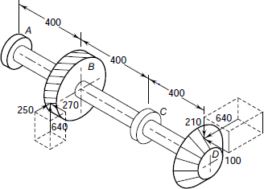
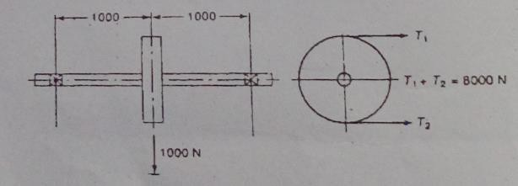

Figure: 1 Figure: 2
2.A transmission shaft supporting a helical gear B and an overhang bevel gear D is shown in figure
- The shaft is mounted on two bearings A and C. The pitch circle diameter of the helical gear is 450mm and the diameter of the bevel gear at the forces is 450mm. Power is transmitted from the helical gear to the bevel gear. The gears are keyed to the shaft. The material of the shaft is steel 45C8 (Sut = 600 and Syt = 380N/mm²). The factors kb and kt of ASME code are 2.0 and 1.5 respectively. Determine the shaft diameter using ASME code. [Nov / Dec 2018]
- A shaft made of AISI 1030 cold drawn steel transmits 50 kW at 900 rpm through a gear. Select an appropriate square key for the gear. [April / May 2018, 2019]
- A 600mm diameter pulley driven by a horizontal belt transmits power through a solid shaft to a 262mm diameter pinion which drives a mating gear. The pulley weighs 1200N to provide some flywheel effect. The arrangement of elements, the belt tensions and components of the gear reactions on the pinion are as indicated in figure below. Determine the necessary shaft diameter using a suitable value for commercial shafting and shock fatigue factors of Kb=2 and Kt=15. [Nov / Dec 2017, 2019]
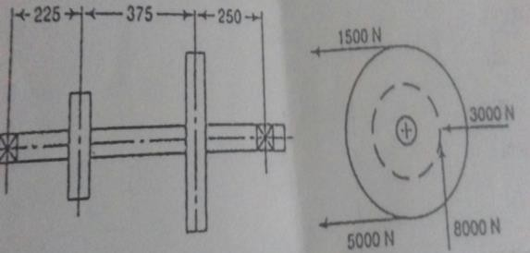
- A hollow shaft of 0.5m outside diameter and 0.3m inside diameter is used to drive a propeller of marine vessel. The shaft is mounted on bearings 6metre apart and it transmits5600kW at 150rpm.

The maximum axial propeller thrust is 500kN and the shaft weighs70kN. Determine (1) The maximum shear stress developed in the shaft, and(2) The angular twist between the bearings.

[Nov / Dec 2016, 2019]
- A solid shaft is supported on two bearing 1.8m apart and rotates at 250rpm. A 20º involute gear D 300mm diameter keyed to the shaft at a distance of 150mm to the left on the right hand bearing. Two pulleys B and C are located on the shaft at a distance of 600mm and 1350mm respectively to the right of the left hand bearing. The diameters of the pulleys B and C are 750mm and 600mm respectively. 30kW is supplied to the gear out of which 18.75kW is taken off at the pulley C and 11.25kW from pulley B. The drive from B is vertically downward while from C the drive is downward at an angle 0f 60º to the horizontal, In both cases the belt tension ratio is 2 and the angle of lap is 180º. The combined fatigue and shock factors for tension and bending may be taken as 1.5 and 2 respectively. Design a suitable shaft taking working stress to be 42MPa in shear and 84MPa in tension.

[April / May 2016, 2019]
- The shaft of length 1m carrying two pulleys 1 and 2 at its left and right ends respectively and it is supported on two bearings A and B which are located 0.25m from the left end and the same 0.25m from the right end respectively. The shaft transmits 7.5kw power at 360rpm from pulley 1 to pulley
2. The diameter of pulleys 1 and 2 are 250 and 500mm respectively. The masses of pulley 1 and 2 are 10kg and 30kg respectively. The belt tension act vertically downward and the ratio of belt tensions on the tight side to slack side for each pulley is 2.5:1.The yield strength of the shaft material σy=380Mpa and FOS is 3.Estimate the suitable diameter of the shaft. [Nov / Dec 2015]
- It is required to design a square key for fixing a gear on a shaft of 30mm dia. The shaft is transmitting 20kw power at 600rpm to the gear. The key is made of steel 50C4 (Syt=460N/mm²) and the FOS is 4. For the key material, the yield strength in compression can be assumed to be equal to the yield strength in Tension. Determine the dimensions of the key. [April / May 2015]
- Design a muff coupling, which is used to connect two steel shafts transmitting 25kw power at 360rpm. The shafts and key are made of plain carbon steel 30C8 (Syt=Syc=400N/mm²).The sleeve is made of grey cast iron FG 200(Sut=200N/mm²). The FOS for shafts and key 4. For sleeve, the FOS is 6, based on ultimate strength. [April / May 2017]
- Design and make neat dimensioned sketch of a muff coupling which is used to connect two steel shafts transmitting 40kW at 350rpm.The material for the shafts and key is plain carbon steel for which allowable shear and crushing stresses may be taken as 40MPa and 80MPa respectively. The material for the muff is cast iron for which the allowable shear stress maybe assumed as 15MPa.

[Nov / Dec 2016]
- Design and draw a protective type of cast iron flange coupling for a steel shaft transmitting 15kW at 200rpm and having an allowable shear stress of 40MPa. The working stress in the bolts should not exceed 30MPa. Assume that the same material is used for shaft and key and that the crushing stress

is twice the value of its shear stress. The maximum torque is 25% greater than the full load torque. The shear stress for cast iron is 14MPa. [May / June 2016, 2019]
- Design a bushed pin type of flexible coupling for connecting a motor and a pump shaft. The following data are provided: Power transmitted = 20kW, speed = 1000rpm, Diameter of the motor and pump shafts=50mm, Allowable bearing pressure in the rubber bush=0.3Mpa.
- Design a cast iron flange coupling for a mild steel shaft transmitting 90kW at 250rpm, the allowable shear stress in the shaft is 40Mpa and the angle of twist is not to exceed ^{1o} in a length of 20metres. The allowable shear stress in the coupling bolt is 30Mpa. Take G=84KN/m^{m2}
- Compare the weight, strength and stiffness of a hollow shaft of the same external diameter as that of solid shaft. The inside diameter of the hollow shaft being half the external diameter. Both the shafts have the same material and length. [Nov / Dec 2013]
15.A rigid type coupling is used to transmit 50kW power at 300rpm. There are six bolts. The outer diameter of the flanges is 220mm, while the recess diameter is 150mm. The coefficient of friction between the flanges is 0.15mm. The bolts are made of steel 45C8 (Syt = 380N/mm²) and the factor of safety is 3. Determine the diameter of the bolts. Assume that the bolts are fitted in large clearance holes. [May/ June 2014, April / May 2018]
16.A steel solid shaft transmitting 15kW 200rpm is supported on two bearings 750mm apart and has two gears keyed to it. The pinion having 30 teeth of 5mm module is located 100mm to the left of the right hand bearing and delivers power horizontally to the right. The gear having 100 teeth of 5mm module is located 150mm to the right of the left hand bearing and receives power in a vertical direction from below. Using an allowable stress of 54MPa in shear, determine the diameter of the shaft.
- A shaft is supported by two bearings placed 1 m apart shown in figure 3. A 600mm diameter pulley is mounted at a distance of 300mm to the right of left hand bearing and this drives a pulley directly below it with the help of belt having maximum tension of 2.25kN. Another pulley 400mm diameter is placed 200mm to the left of right hand bearing and is driven with the help of electric motor and belt, which is placed horizontally to the right. The angle of contact for both the pulleys is 180° and µ
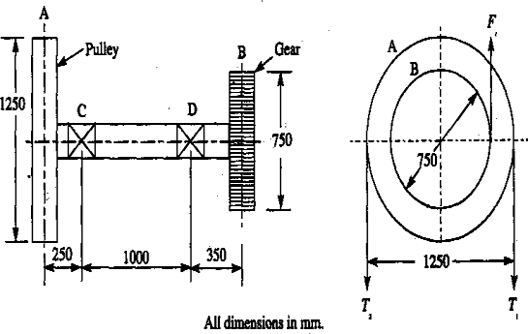
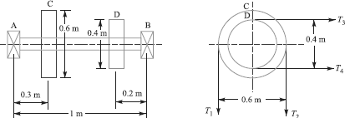
= 0.24. Determine the suitable diameter for a solid shaft, allowing working stress of 63MPa in tension and 42MPa in shear for the material of shaft. Assume that the torque on one pulley is equal to that on the other pulley. [Nov / Dec 2012, 2019]

Figure: 3 Figure: 4

- The figure 4 shows a shaft carrying a pulley A and a gear B and supported in two bearings C and
D. The shaft transmits 20kW at 150rpm. The tangential force Ft on the gear B acts vertically upwards as shown. The pulley delivers the power through a belt to another pulley of equal diameter vertically below the pulley A. The ratio of tensions T1/T2 is equal to 2.5.The gear and the pulley, weight 900N and 2700N respectively. The permissible shear stress for the material of the shaft may be taken as 63MPa. Assuming the weight of the shaft to be negligible in comparison with the other loads, determine its diameter. Take shock and fatigue factors for Bending and torsion as 2 and 1.5 respectively. [Nov / Dec 2012]
- The intermediate shaft in a multi-stage gear box carries a pinion and a gear as show in fig 5. The dimensions and the tooth loads are given in figure. The material of the shaft is plain carbon steel whose yield strength is 380 MPa. The factor of safety is specified as 3. The power flowing through the shaft is approximately 38 kW at a speed of approximately 200 rpm. Determine the size of the shaft on the basis of strength. [June 2021]
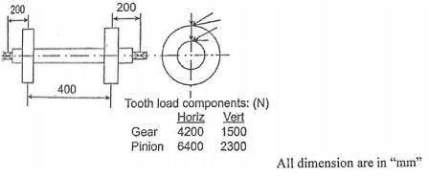

Figure: 5

- A split muff coupling is used to connect two shafts for transmitting 40 kW at 200 rpm. Plain carbon steel is used as material for the shafts whose yield strength is 380 MPa. The number of clamping bolts is 8 and the factor of safety for shafts, bolts and key is 4. The coefficient of friction between the coupling halves is given as 0.3. Calculate (a) diameter of the shafts (b) draw a line sketch of the coupling halves and mark the dimensions, bore diameter, OD, and hub length. (c) Assuming that power is transmitted by friction between the two halves of the coupling, determine the diameter of the clamping bolt. [June 2021]
PART C (C302.2)
- A shaft is supported by two bearings placed 1100mm apart. A pulley of diameter 620mm is keyed at 400mm to the right of the left hand bearing and this drives a pulley directly below it with a maximum tension of 2.75kN. Another pulley of diameter 400mm is placed 200mm to the left of the right hand bearing and is driven with a motor placed horizontally to the right. The angle of contact of the pulleys is 180º and the coefficient of friction between the belt and the pulleys is 0.3. Find the diameter of the shaft. Assume Kb=3, Kt=2.5, Syt=190Mpa, Sut=300Mpa.

- A horizontal nickel steel shaft rests on two bearings, A at the left and B at the right end and carries two gears C and D located at distances of 250mm and 400mm respectively from the centre line of the left and right bearings. The pitch diameter of the gear C is 60 mm and that of gear D is 200mm. The Distance between the centerlines of the bearings is 2400 mm. The shaft transmits 20kW at 120rpm. The power is delivered to the shaft at gear C and is taken out at gear D in such a manner that the tooth pressure Ftc of the gear C and Ftd of the gear D act vertically downwards. Find the diameter of the shaft, if the working stress is 100MPa in tension and 56MPa in shear. The gear C and D weighs 950N and 350N respectively. The combined shock and fatigue factors for bending and torsion may be taken as 1.5 and 1.2 respectively.
- Design a rigid flange coupling to transmit a torque of 250N-m between two coaxial shafts. The shaft is made of alloy steel, flanges out of cast iron and bolts out of steel. Four bolts are used to couple the flanges. The shafts are keyed to the flange hub. The permissible stresses are given below:
Shear stress on shaft =100MPa; Bearing or crushing stress on shaft =250MPa; Shear stress on keys =100MPa; Bearing stress on keys =250MPa; Shearing stress on cast iron = 200MPa; Shear stress on bolts =100MPa. After designing the various elements, make a neat sketch of the assembly indicating the important dimensions. The stresses developed in the various members may be checked if thumb rules are used for fixing the dimensions.

UNIT – III DESIGN OF TEMPORARY&PERMANENTJOINTS
PART A (C302.3)

What is known as “bolt of uniform strength”? [Nov / Dec 2018]
The threaded portion of the bolt is the weakest part and maximum amount of elastic energy is absorbed in this region. The ideal bolt will be one which is subjected to same stress level at different cross-sections in the bolt. It is called the bolt of uniform strength.

List out the advantages of the V-threads. [April / May 2018]
The greatest advantage of square threads is that they have a much higher intrinsic efficiency than trapezoidal threads (Acme or metric trapezoidal). Due to the lack of a thread angle there is no radial pressure, or bursting pressure, on the nut.
- What is Caulking and Fullering process in riveted joints? Why is it used? [April / May 2018] Caulking and fullering processes are used to obtain such leak proof riveted joints. The caulking process is applied to the edges of plates in a lap joint and the edges of strap plate in a butt
joint.
Fullering is similar to the caulking process except for the shape of the tool. The width of the fullering tool is equal to the thickness of the plate being hammered.

State the disadvantages of welded joints. [Nov / Dec 2014, Nov / Dec 2017, Nov / Dec 2018]
  - Since there is an uneven heating and cooling during fabrication, therefore the members may

get distorted or additional stresses may develop.
  - It requires a highly skilled labour and supervision.
  - The inspection of welding work is more difficult.

  - Since no provision is kept for expansion and contraction in the frame, therefore there is a possibility of cracks developing in it.
- What is known as proof load in bolts? [Nov / Dec 2017, April / May 2015] Proof load is defined as the maximum tensile force that can be applied to a bolt that will not result in plastic deformation. Proof load is typically between 85 to 95% of the yield strength.

List the advantages of cotter joint over threaded joints. [April / May 2017, 2019]
  - The assembly and dismantling of parts of the cotter joint is quick and simple.
  - The wedge action develops a very high tightening force, which prevents loosening of parts in service.
  - The joint is simple to design and manufacture.

Why throat is considered while calculating stresses in fillet welds? [April / May 2017, 2019]
The failure of the fillet weld occurs due to shear along the minimum cross section at the throat.
So throat is considered while calculating stresses in fillet welds.

What is the total shear in a double strap butt joint with equal length of straps? [Dec 2015]
The total shear in a double strap butt joint with equal length of strap is two times of single shear.

What is the bending stress induced in the weld when a circular rod of diameter d, welded to a rigid plate by a circular fillet weld of size ‘t’, which is subjected to a bending moment M?
[Nov / Dec 2015]
Bending stress due to bending moment (M) may be calculated by bending stress equation.
𝜎𝑏 = (P x e )/(Zw ) = 𝑀/𝑍
𝑀 = 𝑃 × 𝑒 𝑎𝑛𝑑 𝑍 = (𝜋𝐷²𝑡 ÷ 4)
𝜎_{𝑏}= (4𝑀 ÷ 𝜋𝐷²𝑡)

What are the different applications of screwed fasteners? [Nov / Dec 2016, 2019]
The different applications of screwed fasteners are
a. For readily connecting & disconnecting machine parts without damage, b. The parts can be rigidly connected, c. Used for transmitting power.

State the two types of eccentric welded connections. [May 2016, Dec 2016, Nov / Dec 2013]
  - Welded joints subjected to moment in a plane of the weld.
  - Welded joints subjected to moment in a plane normal to the plane of the weld.

What stresses act on screw fastenings due to static loading? [May / June 2016]
  - Internal stresses due to screwing up ii.forces Stresses due to external forces
iii. Stresses due to combination of above two stresses

What are the two types of fillet weld? [May / June 2016]
  - Longitudinal or parallel fillet weld ii. Transverse fillet weld

What is a gib? What is it provided in a cotter joint? [May / June 2016, Nov / Dec 2013]
Gib is an element made of mild steel with thickness equal to the cotter. A gib is used in combination with the cotter to provide the following advantages. (i)Reduce bending of socket, and ii. Increase the bearing area of contact between the mating surfaces.

What is bearing failure in rivets? [April / May 2015]
Sometimes the rivets do not shear off under the tensile stress, but are crushed. Due to this, the rivet hole becomes of an oval shape and hence the joint becomes loose. The failure of rivets in such a manner is also known as bearing failure.

Why are ACME treads preferred over square thread for power screw? [Dec 2014]
ACME threads is easier to machine and is stronger than the square thread. ACME threads are thicker and wider and they operate better in environment with dirt and debris.

Differentiate with a neat sketch the fillet welds subjected to parallel loading and transverse loading. [May / June 2014]
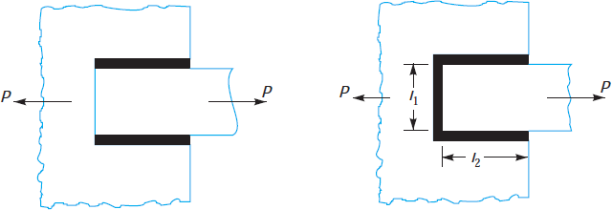
- What are different types of cotter joints? [May / June 2014]
1. Socket and spigot cotter joint, 2. Sleeve and cotter joint, and 3. Gib and cotter joint.

Define butt and lap joint
Butt joint: The joint is made by welding the ends or edges of two plates.
Lap joint: The two plates are overlapping each other for a certain distance and then welded.
Such welding is called fillet weld.

How is a bolt designated?
A bolt is designated by a letter M followed by nominal diameter and pitch in mm.
- What is meant by set screw? [June 2021]
A set screw is screwed through a threaded hole in one part so that its point presses against the other part. This resists the relative motion between the two parts by means of friction between the point of the screw and one of the parts. They may be used instead of key to prevent relative motion between a hub and a shaft in light power transmission members.
22. Differentiate between butt and fillet welded joints. [June 2021]
The main difference between a butt and a fillet weld is the angle between the joining workpieces. If the surfaces to be joined are on the same plane, then it is a butt weld. If the surfaces are perpendicular (with an angle of 90°), then they are usually joined with a fillet weld.

PART B (C302.3)
- The structural connections shown in figure 1 are subjected to an eccentric force P of 10kN with an eccentricity of 500mm from the CG of the bolts. The centre distance between bolts 1 and 2 is 200mm, and the centre distance between bolts 1 and 3 is 150mm. All the bolts are identical. The bolts are made from plain carbon steel 30C8 (Syt = 400N/mm²) and factor of safety is 2.5. Determine the size of the bolts. [April / May 2018]
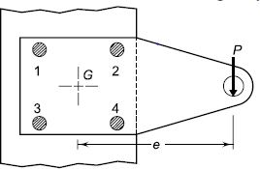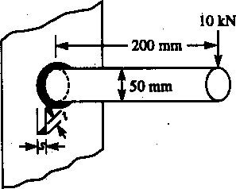
Figure: 1 Figure: 2
- The figure 2 shows a cylindrical rod of 50mm diameter, welded to a flat plate. The cylindrical fillet weld is loaded eccentrically by a force of 10kN acting at 200mm from the welded end. If the size of the weld is 20mm, determine the maximum normal stress in the weld. [Dec 2013,Nov / Dec 2018]
3.A cylindrical steam pressure vessel of 1m inside diameter is subjected to an internal pressure of 2.5MPa. Design a double riveted, double-strap longitudinal butt joint for the vessel. The straps are of equal width. The pitch of the rivets in the outer row should be twice of the pitch of the rivets in the inner row. A zigzag pattern is used for rivets in inner and outer rows. The efficiency of the riveted joint should be at least 70%. The permissible tensile stress for the steel plate of the pressure vessel is 80N/mm². The permissible shear stress for the rivet material is 60N/mm². Assume that the rivets in double shear are1.875 times stronger than in single shear and the joint do not fail by crushing. Calculate:(i) thickness of the plate;(ii) diameter of the rivets;(iii) pitch of the rivets;(iv) distance between inner and outer rows of the rivets;(v) margin;(vi) thickness of the straps; and (vii) efficiency of the joint. Make a neat sketch of the joint showing all calculated values of dimensions
4. An ISA 200 x 100 x 100 angle is welded to a steel plate by means of fillet welds as shown in figure
3. The angle is subjected to a static force of 150kN and permissible shear stress for the weld is 70N/mm². Determine the lengths of the weld at the top and bottom. [Nov / Dec 2017]
- Figure 4 shows a bracket of fixed on a steel column by means of 3 bolts of same size. If the permissible tensile and shear stress are limited to 75N/mm² and 55N/mm² respectively. Find thesize of the bolts.

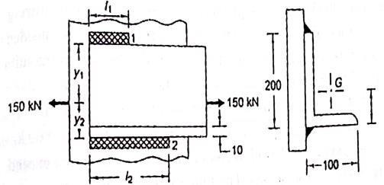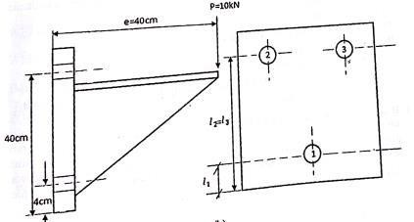
Figure: 3 Figure: 4
- A steam engine of effective diameter 300 mm is subjected to a steam pressure of 1.5 N/mm². The cylinder head is connected by 8 bolts having yield point 330 MPa and endurance limit at 240 MPa. The bolts are tightened with an initial preload of 1.5 times the steam load. A soft copper gasket is used to make the joint leak-proof. Assuming a factor of safety 2, find the size of bolt required. The stiffness factor for copper gasket may be taken as 0.5. [Dec 2015, May 2016]
- A welded connection, as shown in figure 5 is subjected to an eccentric force of 7.5kN. Determine the size of the welds, if the permissible shear stress for the weld is 100N/mm². Assume static conditions. [April / May 2017, Nov / Dec 2018]
- A steel plate subjected to a force of 5kN and fixed to a channel by means of three identical bolts is shown in figure 6. The bolts are made from plain carbon steel for which yield stress in tension is 380 N/mm² and the factor of safety is 3. Determine the size of bolts.

[April / May 2017, Nov / Dec 2018]
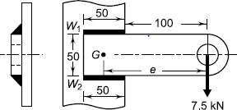
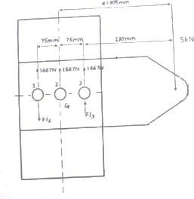
Figure: 5 Figure: 6
- A rectangular steel plate is welded as a cantilever to a vertical column and supports a single concentrated load P, as shown in figure 7. Determine the weld size if shear stress in the same is not to exceed 140MPa. [May / June 2016]

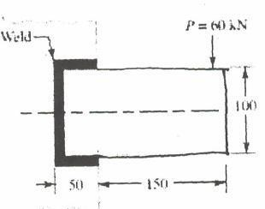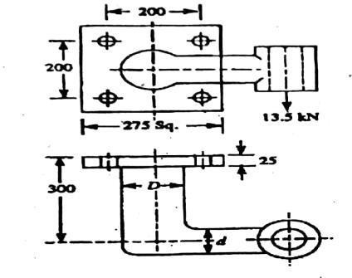
Figure: 7 Figure: 8
- Figure 8 shows a solid forged bracket to carry a vertical load of 13.5kN applied through the centre of hole. The square flange is secured to the flat side of a vertical stanchion through four bolts. Estimate the tensile load on each top bolt and the maximum shearing force on each bolt. Find the bolt size, if the permissible stress is 65MPa in shear. All dimensions in mm. [Nov / Dec 2016] 11.Design a knuckle joint to withstand a load of 100kN. All the parts of the joint are made of the same material with σut = σuc = 480MPa, and τu = 360MPa. Use factor of safety of 6 on ultimate strength. [Nov / Dec 2015, May / June 2016]
- Design a double riveted butt joint with two cover plates for the longitudinal seam of a boiler shell
1.5 in diameter subjected to a steam pressure of 0.95N/mm². Assume joint efficiency as 75%, allowable tensile stress in the plate 90MPa; compressive stress 140MPa; and shear stress in the rivet56MPa. [April / May 2015, May / June 2016, Nov / Dec 2016]
- a) A butt welded joint with ground and flush surface is subjected to tensile load which varies from 50kN to 100kN. Plates are 10mm thick. Determine the length of weld required for over 2,500,000 cycles.
- The figure 9 shows an angle welded to a column and carries a static load F as shown. Determine the ratio of the weld lengths La and Lb and Fa and Fb in terms of F. [April / May 2015, 2019]
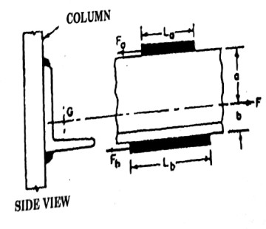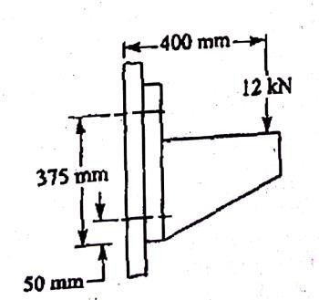
Figure: 9
Figure: 10
- For supporting the travelling crane in a workshop, the brackets are fixed on steel columns as shown in figure 10. The maximum load that comes on the bracket is 12kN acting vertically at a distance of 400mm from the face of the column. The vertical face of the bracket is secured to a column by four bolts, in two rows (two in each row) at a distance of 50mm from the lower edge of the bracket.

Determine the size of the bolts if the permissible value of the tensile stress for the bolt material is 84MPa. Also find the cross section of the arm of the bracket which is rectangular. [Nov / Dec 2013]
- A steel bolt of M16 x 2 is 300mm long carries an impact load of 5000Nm. If the threads stop adjacent to the Nut and E = 2.1 x 10⁵MPa. (i) Find the stress in the root area (ii) Find the stress if the shank area is reduced to root area. [Nov / Dec 2014]
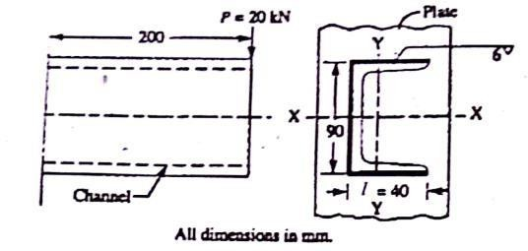
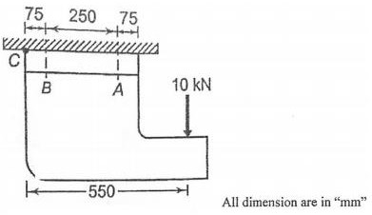
- A cylindrical beam of size 60mm is attached to support by a complete circumferential fillet weld of 6mm. Find (i) torque and (ii) bending moment that can be applied if limiting shear stress is 140MPa. [Nov / Dec 2014]
Figure: 11 Figure: 12
- A cast iron bracket, as shown in fig. 12, supports a load of 10 kN. It is fixed to the horizontal channel by means of four identical bolts, two at A and two at B. The bolts are made of steel 30C8 whose yield strength is 400 MPa and the factor of safety is 6. Determine the major diameter of the bolts if dc = 0.8d. [June 2021]
- A 50mm diameter solid shaft is welded to a flat plate as shown in figure 11. If the size of the weld is 15mm, find the maximum normal and shear stress in the weld. [Nov / Dec 2019]
- A solid circular beam, 25 mm in diameter, is welded to a support by means of a fillet weld as shown in Fig. 13. Determine the leg dimensions of the weld, if the permissible shear stress is 95 MPa. [June 2021]
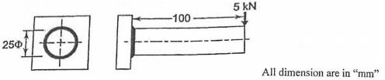

Figure: 13
PART C (C302.3)
- It is required to design a knuckle joint to connect two circular rods subjected to an axial tensile force of 50kN. The rods are co-axial and a small amount of angular moment between their axes is permissible. Design the joint and specify the dimensions of its components. Select suitable materials for the parts. Assume rod materials as 30C8 and FOS = 5. [Nov / Dec 2017, 2019]
- Design and draw a cotter joint to support a load varying from 30kN in compression to 30kN in

tension. The material used is carbon steel for which the following allowable stresses may be used. The load is applied statically. Tensile stress = compressive stress = 50MPa; shear stress = 35MPa and crushing stress = 90MPa.
- Design a double riveted butt joint with two cover plates for the longitudinal seam of a boiler shell 1.5m in diameter subjected to a steam pressure of 0.95N/mm². Assume joint efficiency as 75%, allowable tensile stress in the plate 90MPa; compressive stress 140MPa; and shear stress in the rivet 56MPa.
UNIT- IV DESIGN OF ENERGY STORING ELEMENTS PART
A (C302.4)

Define surge in springs. [April / May 2018]
When the natural frequency of vibrations of the spring coincides with the frequency of external periodic force, which acts on it, resonance occurs. In this state, the spring is subjected to a wave of successive compressions of coils that travels from one end to the other and back. This type of vibratory motion is called ‘surge’ of spring.

While designing helical springs, K is introduced in the shear stress equation, why?
[Nov / Dec 2017, Nov / Dec 2018]
K is the factor for combined effect due to direct shear stress and stress concentration. So K is introduced in the shear stress equation, while designing helical springs.
K = Ks Kc
Where
Ks = Factor to account for direct shear stress
Kc = Factor to account for stress concentration due to curvature effect.

What is the purpose of flywheel? [Nov / Dec 2015, April / May 2018]
A flywheel used in machine serves as a reservoir which stores energy during the period when the supply of energy is more than the requirement and releases it during the period when the requirement of energy is more than the supply.
- What is nipping of leaf springs? [May / June 2016, Nov / Dec 2018]
By giving a greater radius of curvature to the full length leaves than graduated leaves, before the leaves are assembled to form a spring. During that a gap or clearance will be left between the leaves. This initial gap is called nip. This process is called nipping.

Brief why fly wheels are used in punching machines. [Nov / Dec 2017, 2019]
Punching machine driven by an electric motor. The function of flywheel is to store energy during the ideal portion of the work cycle by increasing its speed and delivers this energy during the peak load period of punching.

What are the forces acting on connecting rod? [April / May 2017]
  - Inertia of the connecting rod.
  - The friction force in the dudgeon and crank pin bearings.
  - Force due to gas or steam pressure and inertia of reciprocating parts.

Sketch the stresses induced in the cross section of a helical spring, considering Wahl’s effect.
[April / May 2017]
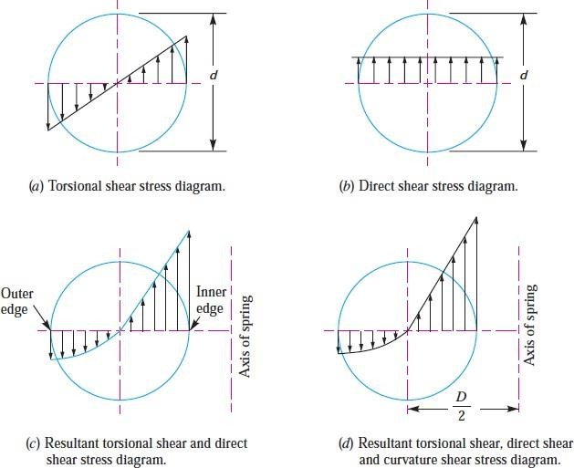

What type of spring is used to maintain an effective contact between a cam and a reciprocating roller or flat faced follower? [Nov / Dec 2015]
An open coil helical compression spring is used to maintain an effective contact between a cam and a reciprocating roller or flat faced follower.

State any two functions of springs. [Nov / Dec 2016, 2019]
i. To measure forces in spring balance, meters and engine indicators. ii. To store energy.

How does the function of flywheel differ from that of governor? [Nov / Dec 2016, 2019]
A governor regulates the mean speed of an engine when there are variations in the mean loads. It automatically controls the supply of working fluid to engine with the varying load conditions and keeps the mean speed within the limits. It does not control the speed variation caused by the varying load. A flywheel does not maintain constant speed.

Define spring rate. (or) What is stiffness of spring? [May / June 2016]
The spring rate (or stiffness or spring constant) is defined as the load required per unit deflection of the spring. Mathematically,
Spring rate, k = W / δ
Where W = Load and
δ = Deflection of the spring.
- Define the term ‘fluctuation of speed’ and ‘fluctuation of energy’. [May 2016, May 2014] Fluctuation of speed: The difference between the maximum and minimum speeds during a

cycle is called maximum fluctuation of speed.
Fluctuation of energy: The difference between maximum and minimum energy during the is called fluctuation of energy (∆E)

State the purpose of using concentric springs. [April / May 2015]
  - Railway car suspension.
  - Automobile clutches.
  - Aircraft Valves.
  - Heavy duty engine valves.

Define (a) Coefficient of fluctuation of speed (b) Coefficient of fluctuation of energy.
[Nov / Dec 2014]
The ratio of maximum fluctuation of speed to the mean speed is called coefficient of fluctuation of speed, K^{s}.
The ration of fluctuation of energy to the mean energy is called coefficient of fluctuation of
energy.
KE = (Emax – Emin) / E = ∆E / E

Distinguish between close coiled and open coiled springs. [Nov / Dec 2014, 2019]

Open coiled spring | Closed coiled spring
The wires are coiled such that there is a gap between the two consecutive turns. | The spring wires are coiled very closely,  each turn is nearly at right angles to the axis of helix.
Helix angle is large (>10º) | Helix angle is less than 10º
Both torsional and bending stresses are significant. | Only torsional stresses are predominant.
- A helical spring of rate 12N/mm is mounted on the top of another spring of rate 8N/mm. Find the force required to give a deflection of 50mm. [Nov / Dec 2013]
Given Data: Stiffness of first spring, q1 = 12N/mm; Stiffness of second spring, q2 = 8N/mm; Deflection, y = 50 mm.

Solution:
When two springs are arranged in series,
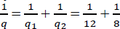
Total stiffness, q = 4.8 N/mm, Stiffness, q = Load / Deflection 4.8 = P / 50, P = 240N

What is the purpose of flywheel that is used in an IC engine?
[Nov/Dec 2013, April/May 2019]
A flywheel is a heavy rotating mass which is placed between the power source and the driven member to act as a reservoir of energy. The primary function of flywheel is to act as an “energy accumulator”. It will be absorb energy when demand is less than the supply of energy and will release it when the demand is more than the energy being supplied.

What is meant by semi elliptical leaf springs? [May / June 2014]
The spring consists of number of leaves, which are held together by U-clips. The long leaf fastened to the supported is called master leaf. Remaining leaves are called graduated leaves.

What is the advantage of leaf spring over helical spring?
The advantage of leaf spring over helical spring is that the end of the spring may be guided along a definite path as it deflects to act a structural member in addition to energy absorbing device.

Define free length.
Free length of the spring is the length of the spring when it is free or unloaded condition. It is equal to the solid length plus the maximum deflection or compression plus clash allowance.
Lf = solid length + Ymax + 0.15 Ymax

Name the common types of mechanical springs. [June 2021]
1. Helical springs 2. Torsion springs 3. Laminated or leaf springs 4. Disc or Belleville springs

A flywheel connected to a punching machine has to supply energy of 400 N-m while running at a mean angular speed of 20 rad/s. If the total fluctuation of speed is not to exceed ±2%, what is the mass moment of inertia of the flywheel? [June 2021]
Given Data
Cs = ±2% = 0.04, ΔE = 400 N-m ω = 20 rad/s Maximum Fluctuation of Energy (ΔE) = Iω² Cs 400 = I * 20² * 0.04
I = 25 Kg – m²
PART B (C302.4)
- At the bottom of a mine shaft, a group of 10 identical close coiled helical springs are set in parallel to absorb the shock caused by the falling of the cage in case of a failure. The loaded cage weighs 75kN, while the counter weight has a weight of 15kN. If the loaded cage falls through a height of 50 meters from rest, find the maximum stress induced in each spring if it is made of 50mm diameter steel rod. The spring index is 6 and the number of active turns in each spring is 20. Modulus of rigidity, G = 80kN/mm². [Nov / Dec 2018]
- A helical compression spring, made of circular wire, is subjected to an axial force, which varies from 2.5kN to 3.5kN. Over this range of force, the deflection of the spring should be approximately 5 mm. The spring index can be taken as 5. The spring has square and ground ends. The spring is made of patented and cold-drawn steel wire with ultimate tensile strength of 1050N/mm² and modulus of rigidity of 81370N/mm². The permissible shear stress for the spring wire should be taken as 50% of the ultimate tensile strength. Design the spring and calculate(i) wire diameter;(ii) mean coil diameter;(iii) number of active coils;(iv) total number of coils;(v) solid length of the spring;(vi) free length of the spring;(vii) required spring rate; and(viii) actual spring rate [April / May 2018]
- The turning moment diagram of a multi-cylinder engine is drawn with a scale of (1mm= 1°) on the abscissa and (1mm = 250N-m) on the ordinate. The intercepted areas between the torque developed by the engine and the mean resisting torque of the machine, taken in order from one end are – 350,
+ 800, – 600, + 900, – 550, + 450 and–650mm². The engine is running at a mean speed of 750rpm

and the coefficient of speed fluctuations is limited to 0.02. A rimmed flywheel made of grey cast iron FG 200 (r = 7100kg/m³) is provided. The spokes, hub and shaft are assumed to contribute10% of the required moment of inertia. The rim has rectangular cross-section and the ratio of width to thickness is 1.5.Determine the dimensions of the rim. [April / May 2018]
- A spring loaded safety valve for a boiler is required to blow-off at a pressure of 0.8MPa. The diameter of the valve set is 90mm and maximum lift of the valve is 10mm. Design a suitable spring for the valve assuming the spring index as 7. Take allowable shear stress as 420MPa.

[Nov 2017, 2019]
- A punching machine makes 25 working strokes per minute and is capable of punching 25mm diameter holes in 18mm thick steel plates having ultimate shear strength of 300kg/cm³. The punching operation takes place during 1/10th of a revolution of the crank shaft. Estimate the power needed for the driving motor, assuming a mechanical efficiency of 95%. Determine suitable dimensions for the rim cross-section of the flywheel, which is to revolve at 9 times the speed of the crank shaft. The permissible coefficient of fluctuation of speed is 0.1. The flywheel is to be made of cast iron having a working stress (tensile) of 60kg/cm³ and density of 7.25gm/cu. cm. The diameter of the flywheel must not exceed 149cm owing to space restrictions. The hub and the spokes may be assumed to provide 5% of the rotational inertia of the wheel. Check for the centrifugal stress induced in the rim.

[Nov / Dec 2017]
- A helical compression spring of the exhaust valve mechanism is initially compressed with a pre- load of 375N. When the spring is further compressed and the valve is fully opened, the torsional shear stress in the spring wire should not exceed 750N/mm². Due to space limitations, the outer diameter of the spring should not exceed 42mm. The spring is to be designed for minimum weight. Calculate the wire diameter and the mean coil diameter of the spring. [April / May 2017]
- A punching machine carries out punching 10 holes per minute. Each hole of 36mm diameter in 16mm thick plate requires 7N-m of energy/mm² of the sheared area. The punch has a stroke of 90mm. Determine the power of the motor required to operate the machine. It the total fluctuation of speed is not to exceed 2.5% of the mean speed; determine the mass of the flywheel. The mean speed of the flywheel is 15m/s. [April / May 2017]
- A railway wagon moving at a velocity of 1.5m/s is brought to rest by a bumper consisting of two helical springs arranged in parallel. The mass of the wagon is 1500kg. The springs are compressed by 150mm in bringing the wagon to rest. The spring index can be taken as 6. The springs are made of oil-hardened and tempered steel wire with ultimate tensile strength of 1250N/mm² and modulus of rigidity of 81.370N/mm². The permissible shear stress for the spring wire can be taken as 50% of the ultimate tensile strength. Design the spring and calculate: (i) wire diameter; (ii) mean coil diameter;
    - number of active coils; (iv) total number of coils; (v) solid length; (vi) free length; (vii) pitch of

the coil. [Nov / Dec 2015, April/May 2019]
- A 5kW induction motor, running at 960rpm operates a riveting machine. The flywheel fitted to it, is of mass 120kg, with radius of gyration equal to 0.35m. Each riveting takes 1 second and requires 9kW. Determine (i) the number of rivets formed per hour and (ii) the reduction in speed of the flywheel, after the riveted operation. [Nov / Dec 2015]
- The areas of the turning moment diagram for one revolution of a multi-cylinder engine with reference to the mean turning moment, below and above the line, are -32, + 408, - 267, + 333, - 310,
+ 226, - 374, + 260 and - 244mm². The scale for abscissa and ordinate are: 1mm = 2.4° and 1mm = 650N-m respectively. The mean speed is 300rpm with a percentage speed fluctuation of± 1.5%. If the hoop stress in the material of the rim is not to exceed 5.6MPa, determine the suitable diameter and cross-section for the flywheel, assuming that the Width is equal to 4 times the thickness. The density of the material may be taken to be 7200kg/m³. Neglect the effect of the boss and arms.

[Nov / Dec 2016]
- Design a leaf spring for the following specifications: Total load = 140kN; Number of springs supporting the load = 4; Maximum number of leaves = 10; Span of the spring = 1000mm; Permissible deflection = 80mm. Take Young's modulus, E = 200kN/mm² and allowable stress in spring material as 600MPa. [Nov / Dec 2016]
- A safety valve of 60mm diameter is to blow off at a pressure of 1.2N/mm². It is held on its seat by a close coiled helical spring. The maximum lift of the valve is 10mm. Design a suitable compression spring of spring index 5 and providing an initial compression of 35mm. The maximum shear stress in the material of the wire is limited to 500MPa. The modulus of rigidity for the spring material is 80kN/mm². Calculate: 1. Diameter of the spring wire, 2. Mean coil diameter, 3. Number of active turns, and 4. Pitch of the coil. [Nov / Dec 2016, 2019]
- A punching press pierces 35 holes per minute in a plate using 10kN-m of energy per hole during each revolution. Each piercing takes 40 per cent of the time needed to make one revolution. The punch receives power through a gear reduction unit which in turn is fed by a motor driven belt pulley 800mm diameter and turning at 210rpm. Find the power of the electric motor if overall efficiency of the transmission unit is 80 per cent. Design a cast iron flywheel to be used with the punching machine for a coefficient of steadiness of 5, if the space considerations limit the maximum diameter to 1.3m. Allowable shear stress in the shaft material is 50MPa, Allowable tensile stress for cast iron is 4MPa, and Density of cast iron is 7200kg /m³. [Nov / Dec 2016]
- A helical compression spring made of oil tempered carbon steel is subjected to a load which varies from 400N to 1000N. The spring index is 6 and the design factor of safety is 1.25. If the yield stress in shear is 770MPa and endurance stress in shear is 350MPa, find: 1. Size of the spring wire, 2.Diameters of the spring, 3. Number of turns of the spring, and 4. Free length of the spring. The

compression of the spring at the maximum load is 30mm. The modulus of rigidity for the spring material may be taken as 80kN/mm². [Nov / Dec 2013, May / June 2016]
- A single cylinder double acting steam engine delivers 185kW at 100rpm. The maximum fluctuation of energy per revolution is 15 per cent of the energy developed per revolution. The speed variation is limited to 1 per cent either way from the mean. The mean diameter of the rim is 2.4m. Design and draws two views of the flywheel. [Nov / Dec 2013, May / June 2016]
- Design a helical compression spring to sustain an axial load of 3kN. The deflection is 60 mm. spring index is 6. The shear stress is not to exceed 300MPa. Rigidity modulus for spring material is 81GPa. [April / May 2015, Nov / Dec 2018]
- Design a closed coiled helical spring subjected a tensile load of magnitude varying from 2500N to 3000N and the axial deflection of spring for this range of load is 6.5mm. Design the spring taking the spring index as 6 and safe stress for material equal to 465MPa. [Nov / Dec 2014]
- Design a CI flywheel for a four stroke engine developing 150kW at 200rpm. Calculate the mean diameter of the flywheel if the hoop stress is not to exceed 4MPa. Total fluctuation of speed is to be 4% of the mean speed. Work done during the power stroke may be assumed to be 1.5 times the average work done during the cycle. Density of CI is 7200 kg/m³. [Nov / Dec 2014, 2019]
- A safety valve, 40 mm in diameter, is to blow off at a pressure of 1.2 MPa. It is held on its seat by means of a helical compression spring, with initial compression of 20 mm. The maximum lift of the valve is 12 mm. The spring index is 6. The spring is made of cold-drawn steel wire with ultimate tensile strength of 1400 MPa. The permissible shear stress can be taken as 50% of this strength. G =
81.37 GPa. Calculate (i) wire diameter, (ii) mean coil diameter and (iii) number of active coils.

[June 2021]
- A semi-elliptic leaf spring used for automobile suspension consists of three extra full-length leaves and 15 graduated-length leaves, including the master leaf. The centre-to-centre distance between two eyes of the spring is 1 m. The maximum force that can act on the spring is 75 kN. For each leaf, the ratio of width to thickness is 9:1. The modulus of elasticity of the leaf material is 207 GPa. The leaves are pre-stressed in such a way that when the force is maximum, the stresses induced in all leaves are same and equal to 450 MPa. Determine (i) the width and thickness of the leave: (ii) the initial nip and (iii) the initial pre-load required to close the gap C between extra full-length leaves and graduated length leaves. [June 2021]
PART C (C302.4)
1.Explain why the standard I-section is chosen for designing of connecting rod over other cross section without sacrificing the fundamentals and write the design equation for connecting rod based on crippling load. [April / May 2018]

2.A single cylinder double acting steam engine delivers 185kW at 100rpm. The maximum fluctuation of energy per revolution is 15 per cent of the energy developed per revolution. The speed variation is limited to 1 per cent either way from the mean. The mean diameter of the rim is 2.4m. Design and draws two views of the flywheel.
- A mechanism used in printing machinery consists of a tension spring assembled with a preload of 30N. The wire diameter of spring is 2mm with a spring index of 6. The spring has 18 active coils. The spring wire is hard drawn and oil tempered having following material properties: Design shear stress = 680MPa Modulus of rigidity = 80kN/mm². Determine: 1. the initial torsional shear stress in the wire; 2. spring rate; and 3. the force to cause the body of the spring to its yield strength.
- A rimmed flywheel made of grey cast iron FG 200 whose density is 7100 kg/m3 is required to keep down fluctuations in speed from 200 to 220 rpm. The cyclic fluctuation in energy is 30,000 N-m, while the maximum torque during the cycle is 75,000 N-m. The outside diameter of the flywheel should not exceed 2 m. It can be assumed that there are six spokes and the rim contributes 90% of the required moment of inertia. The cross- section of the rim is rectangular and the ratio of width to thickness is 2. Determine the dimensions of the rim. Assuming suitable cross-section for spokes, calculate the stresses in the rim and spokes. [June 2021]
- Determine the dimensions of cross-section of the connecting rod for diesel engine with following data : Cylinder bore = 100 mm Length of connecting rod = 350 mm Maximum gas pressure = 4 MPa Factor of safety
=6. [June 2021]
UNIT – V DESIGN OF BEARINGS & MISCELLANEOUS ELEMENTS
PART A (C302.5)

Give two applications where the inner race is rotating and outer race is stationary in rolling contact bearings. [Nov / Dec 2018]
  - Profiled rail guides,
  - Crossed roller slides, and
  - Ball screws

What are essential conditions for wedge film formation in Hydro dynamic bearing?
[April / May 2018]
- The lubricant obeys Newton's law of viscous flow.
- The pressure is assumed to be constant throughout the film thickness.
- The lubricant is assumed to be incompressible.
- The viscosity is assumed to be constant throughout the film.
- The flow is one dimensional, i.e. the side leakage is neglected.

Define load factor and explain its significance in related to bearing selection. [May 2018]
The forces acting on the bearing are calculated by considering the equilibrium of forces in vertical and horizontal planes. These elementary equations do not take into consideration the effect of dynamic load. The forces determined by these equations are multiplied by a load factor to determine the dynamic load carrying capacity of the bearing. Load factors are used in applications involving gear, chain and belt drives.

List the advantages of hydrostatic bearings. [Nov / Dec 2017, Nov / Dec 2018]
  - Heavy radial load can be carried.
  - Low initial torque, hence a light motor enough to rotate shafts under heavy loads.
  - Reduced initial friction.

What type of bearings can take axial load? [Nov / Dec 2017]
One directional flat race ball bearing
One-directional grooved race ball bearing Two-directional grooved race ball bearing

What are anti-friction bearings? [April / May 2017, 2019]
An antifriction bearing is a bearing that contains moving elements to provide a low friction support surface for rotating or sliding surfaces. Antifriction bearings are commonly made with hardened rolling elements (balls and rollers) and races. A race is the bearing surface in an antifriction bearing that supports rolling elements during rotation. A separator is an antifriction bearing component used to maintain the position and alignment of rolling elements.

Plot the friction induced in various bearings based on shaft speed. [April / May 2017]
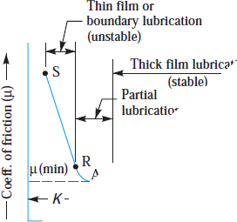

- What is meant by square journal bearing? [Nov / Dec 2015]
When the length of journal is equal to the diameter of the journal, then the bearing is called square bearing.

Give an example for anti-friction bearing. [Nov / Dec 2015, 2019]
- Ball Bearing
- Roller Bearing

Classify the types of bearings. [May / June 2014, Nov / Dec 2016]
- Depending upon the type of load coming upon the shaft:
  - Radial bearing b. thrust bearings.
- Depending upon the nature of contact:
  - Sliding contact b. Rolling contact bearings or Antifriction bearings.

Define the term Reliability of a Bearing? [Nov / Dec 2016]
The reliability (R) is defined as the ratio of the number of bearings which have successfully completed L million revolutions to the total number of bearings under test. Sometimes, it becomes necessary to select a bearing having a reliability of more than 90%.

What is meant by hydrodynamic lubrication? [May / June 2016]
In hydrodynamic lubrication systems, a thin film of lubrication is created between the shaft and bearing. In this type of bearing, there is no need to supply lubricants under pressure and theonly requirement is sufficient and continuous supply of the lubricant.

What are the advantages of Rolling Contact Bearings over Sliding Contact Bearings?
[May / June 2016, 2019]
  - They produce low starting and running friction except at very high speeds.
  - It can withstand momentary shock loads.
  - Accuracy of shaft alignment is high.
  - Low cost of maintenance is sufficient as no lubrication is required while in service.
  - The bearings have small overall dimensions.
  - They provide good reliability of service.
  - They are easy to mount and erect.
  - They provide more cleanliness.

What is meant by journal bearing? [May / June 2016]
A journal bearing is a sliding contact bearing which gives lateral support to the rotating shaft.

What do you meant by life of an individual bearing? [May / June 2016]
The life of an individual ball (or roller) bearing may be defined as the number of revolutions (or hours at some given constant speed) which the bearing runs before the first evidence of fatigue develops in the material of one of the rings or any of the rolling elements.

What is sommerfield number? State its importance in the design of journal bearing?
[April / May 2015, 2019]
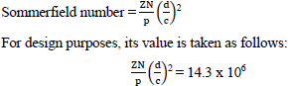
The Sommerfeld number is a dimensionless parameter used extensively in the design of journal bearings. Mathematically,

Summerfield number contains many parameters needed for designer to hydrodynamic lubrication analysis.

In hydrodynamic bearing, what are factors which influence the formation of wedge fluid film? [Nov / Dec 2014]
  - A continuous supply of oil.
  - A relative motion between the two surfaces in a direction approximately tangential to the surfaces.
  - The ability of one of the surfaces to take up a small inclination to the other surface in the

direction of the relative motion.
  - The line of action of resultant oil pressure must coincide with the line of action of the external load between the surfaces.

Define static Capacity of Bearing. [Nov / Dec 2014]
It is defined as load acting on a non-rotating bearing under which permanent deformation is 0.0001 times the ball or roller diameter.

What is meant by life of anti-friction bearing? [Nov / Dec 2013]
Life of anti-friction bearing is defined as the number of revolutions or the time in hours at a specified speed that the bearing can attain before the first fatigue occurs.

What is meant by journal bearing? [May / June 2014]
A journal bearing is a sliding contact bearing which gives lateral support to the rotating shaft.

What are the required properties of bearing materials? [Nov / Dec 2012]
Bearing material should have the following properties.
i. High compressive strength, ii. Low coefficient of friction, iii. High thermal conductivity, iv. High resistance to corrosion, v. sufficient fatigue strength, vi. It should be soft with a low modulus of elasticity, vii. Bearing materials should not get weld easily to the journal material.

What is meant by static load carrying capacity of a bearing? [June 2021]
Static load capacity is the amount of load that a bearing can endure before a bearing raceway causes a permanent distortion of 0.01% of the diameter of a rolling element. The static load capacity of a bearing is always denoted by Co, and this value is given to make sure the load does not cross the static load capacity.
(Or)
The basic static load rating is defined as the static radial load (in case of radial ball or roller bearings) or axial load (in case of thrustball or roller bearings) which corresponds to a total permanent deformation of the ball (or roller) and race, at the most heavily stressed contact, equal to 0.0001 times the ball (or roller) diameter.

Classify the bearings depending upon type of rolling element. [June 2021]
1. Ball bearing 2. Roller bearings 3. Radial ball bearing 4. Thrust ball bearings

PART B (C302.5)
- The following data is given for a full hydrodynamic bearing used for electric motor:
Radial load = 1200N; journal speed = 1440rpm; journal diameter = 50mm; static load on the bearing
= 350N; the values of surface roughness of the journal and the bearing are 2 and 1 micron respectively. The minimum oil film thickness should be five times the sum of surface roughness of the journal and the bearings. Determine (i) length of the bearing;(ii) radial clearance;(iii) minimum oil fi lm thickness;(iv) viscosity of lubricant; and (v) flow of lubricant. Select suitable oil for this application assuming the operating temperature as 65°C.

- A shaft transmitting 50kW at 125rpm from the gear G1 to the gear G2 and mounted on two single- row deep groove ball bearings B1 and B2 is shown in figure 1. The gear tooth forces arePt1 = 15915N, Pr1 = 5793N, Pt2 = 9549N and Pr2 = 3476N. The diameter of the shaft at bearings B1 and B2 is 75mm. The load factor is 1.4 and the expected life for 90% of the bearings is 10000h. Select suitable ball bearings. [April / May 2018]
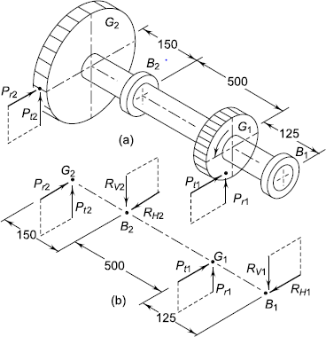

Figure: 1
- A 100mm diameter full journal bearing supports a radial load of 5000N. The bearing is 100mm long and operates at 400rpm. Permissible minimum film thickness 25micron.Diametral clearance 152microns. Using Raimond & Boyd curves find (i) viscosity of suitable oil (ii) μ (iii) heat generation rate (iv) amount of oil pumped through bearing (v) amount of end leakage (vi) rise in temperature of oil. [Nov / Dec 2015, Nov / Dec 2018]
- A roller bearing is to be selected to withstand a radial load of 4000N and have an L10 life of 1200hours at a speed of 600rpm. (i) What is the basic dynamic load rating of the bearing to be selected? (ii) If the reliability requirement is 99%, what load rating would be used? Take b = 1.17 and V = S = 1. [Nov / Dec 2016, Nov / Dec 2018]
- Design a journal bearing for a 49.9mm diameter journal. It is ground and hardened and is rotating at 1500 rpm in a bearing of a diameter and length 50 mm. The inlet temperature of oil 65ºC. Determine
a) maximum radial load that the journal can carry b) power loss. [April / May 2017, Nov / Dec 2017]
- A deep groove ball bearing No. 6308 selected for a particular application, carries a radial load of 2900N and a thrust load of 1800N; both being steady. The inner race of the bearing rotates at 900rpm. The bearing is required to have a minimum life of 9000 hours. Check whether the bearing selected can serve the purpose. [Nov / Dec 2017]
- A ball bearing is subjected to a radial load of 10kN and a thrust load of 5kN. The inner ring rotates at 1000rpm. The average life is to be 5000hours. What basic load rating must be used to select a bearing for this purpose? Take Fa / Co = 0.5 and assume service factor 1.5. [April / May 2017]
- Select a single row deep groove ball bearing for a radial load of 4000N and an axial load of 5000N, operating at a speed of 1600rpm for an average life of years at 10 hours per day. Assume uniform and steady load. [Nov / Dec 2015, Nov / Dec 2016]

- Design a journal bearing for 12MW, 1000rpm steam turbine, which is supported by two bearings. Take the atmospheric temperature as 16ºC and operating temperature of oil as 60ºC. Assume viscosity of oil as 23 centistokes. [May / June 2016, Nov / Dec 2016]
- Design a journal bearing for a centrifugal pump from the following data: Load on the journal = 20,000N; Speed of the journal = 900rpm; Type of oil is SAE 10, for which the absolute viscosity at 55°C= 0.017kg/m-s; Ambient temperature of oil = 15.5°C; Maximum bearing pressure for the pump
= 1.5N/mm². Calculate also mass of the lubricating oil required for artificial cooling, if rise of temperature of oil be limited to 10°C. Heat dissipation coefficient = 1232W/m²/°C.

[Nov / Dec 2013, Nov / Dec 2016, 2019]
- Select a suitable deep groove ball bearing for supporting a radial load of 10kN and an axial load of 3kN for a life of 4000 hours at 800rpm. Select from series 63. Calculated the expected life of the selected bearing. [May / June 2016]
- Load on a hydrodynamic full journal bearing is 30kN. The diameter and speed of the shaft are150mm and 1200mm respectively. Diametral clearance 0.2mm. sommerfield number is 0.631 L/D ratio 1: 1. Calculate temperature rise of oil, quantity of the oil, heat generated and type of oil required.

[April / May 2015]
- A 50mm diameter journal bearing rotates at 1500rpm, L/D = 1, radial clearance is 0.05mm, minimum film thickness = 0.01mm. Calculate the maximum radial load that the journal bearing can carry and still operate under hydrodynamic condition. For this load, calculate the power lost in friction and increase in the oil pressure. Assume Hg = Hd. Absolute viscosity = 20 x 10³ pas, sp. Gravity of oil 0.8, sp. Heat of oil 2.1kJ/kgºC. [Nov / Dec 2014]
- Find the rated load of a deep groove ball bearing for the following load cycle.

Sl. | Radial Load (N) | Axial Load (N) | % of Time
1 | 3000 | 1000 | 15
2 | 3500 | 1000 | 20
3 | 3500 | 10 | 30
4 | 500 | 2000 | 35
Also find the 90% life of ball bearing if bearing used is 6207 with dynamic capacity 19620N.
[Nov/Dec 2014] 15.Determine the dimensions of an I-section connecting rod for a petrol engine from the following data: Diameter of the piston = 110mm; Mass of the reciprocating parts = 2kg; Length of the connecting rod from center to centre = 325mm, Stroke length = 150mm, rpm = 1500 with possible over speed of 2500; Compression ratio = 4:1; Maximum explosion pressure = 2.5N/mm².

[Nov / Dec 2013]
  - A single-row deep groove ball bearing is subjected to a radial force of 8 kN and thrust force of 3 kN. The values of X and Y factors are 0.56 and 1.5 respectively. The shaft rotates at 1200 rpm. The diameter of the shaft is 75 mm and bearing No. 6315 (Dynamic load carrying capacity, C = 112 000

N) is selected for the application. i) Estimate the life of this bearing with 90% reliability ii) Estimate the reliability for 20,000 hr life [June 2021]
  - Following data is given for a 360º hydrodynamic bearing: Radial load = 3.2 kN. Journal speed = 1490 rpm. L/d ratio = 1. Unit bearing pressure = 1.3 MPa Radial clearance = 0.05 mm. Viscosty of the lubricant = 25 cP. Assuming that the total heat generated in the bearing is carried by the total oil flow in the bearing, calculate (i) Journal diameter and bearing length, (ii) coefficient of friction, (iii) power lost in friction and (iv) minimum oil film thickness. [June 2021]
PART (C302.5)
- A full journal bearing of 50mm diameter and 100mm long has a bearing pressure of 1.4N/mm². The speed of the journal is 900rpm and the ratio of journal diameter to the diametral clearance is 1000. The bearing is lubricated with oil whose absolute viscosity at the operating temperature of 75°C may be taken as 0.011kg/m-s. The room temperature is 35°C. Find: 1. The amount of artificial cooling required, 2. The mass of the lubricating oil required, if the difference between the outlet and inlet temperature of the oil is 10°C. Take specific heat of the oil as 1850J/kg/°C. [Nov / Dec 2019]
- The rolling contact ball bearing is to be selected to support the overhung countershaft. The shaft speed is 720rpm. The bearings are to have 99% reliability corresponding to a life of 24,000hours. The bearing is subjected to an equivalent radial load of 1kN. Consider life adjustment factors for operating condition and material as 0.9 and 0.85 respectively. Find the basic dynamic load rating of the bearing from manufacturer's catalogue, specified at 90% reliability.
- Design a journal bearing for a centrifugal pump with the following data:
Diameter of the journal= 150mm, Load on bearing= 40kN, Speed of journal = 900rpm

[April /May 2019]

